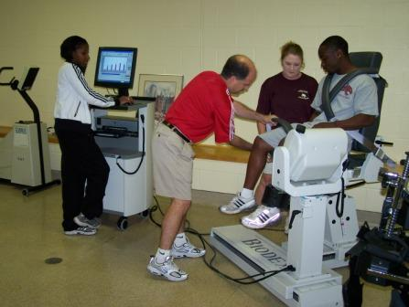**Athletic Training Research Laboratory**

Department of Health, Physical Education, and Recreation

**LOWER EXTREMITY BIOMECHANICS STUDY**

We are looking for physically active females between the ages of 18 – 25 who participate in at least 30 minutes of physical activity 3 times a week to participate in this Thesis study. We are investigating the strength of the thigh muscles and the effects that fatigue might have on a lowering exercise. Your participation will involve an initial meeting lasting approximately 30 minutes to go over the consent form and answer any questions you may have. The study itself will last about 60 minutes and will be conducted in the Athletic Training Research Laboratory. We will test the thigh muscle strength and record the lowering exercise pre and post the fatigue exercise. Please contact Heather Wedding for more details.

Heather Wedding

[hm1110@txstate.edu](mailto:hm1110@txstate.edu)

512-245-5419